8.9 Practice Name: _________________________

Graph the following and provide all required information.

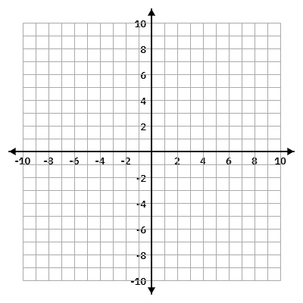
1. $f(x)=\frac{x^{2}-9}{x^{2}-x-6}$
Domain: ______________________

VA: __________ HA: ___________

Holes: _______________________

Range: ______________________

x-int: __________ y-int: _________

Asymptotic Behavior:


2. $f(x)=\frac{x^{2}+2x-3}{x^{2}+7x+12}$
Domain: ______________________

VA: __________ HA: ___________

Holes: _______________________

Range: ______________________

x-int: __________ y-int: _________

Asymptotic Behavior:


3. $f(x)=\frac{-1}{x-2}-3$

Domain: ______________________

VA: __________ HA: ___________

Holes: _______________________

Range: ______________________

x-int: __________ y-int: _________

Asymptotic Behavior:


4. $f(x)=\frac{x+4}{x^{2}-16}$
Domain: ______________________

VA: __________ HA: ___________

Holes: _______________________

Range: ______________________

x-int: __________ y-int: _________

Asymptotic Behavior:

